ChemTec: Gas Chromatography
The Current State of Air Monitoring
The American Lung Association’s (ALA) 2015 “State of the Air” report stated, “Nearly 138.5 million people—almost 44 percent of the nation—live where pollution levels are too often dangerous to breathe.” It’s especially bad in the western USA, with many urban areas in California suffering high levels of air pollution. Overall, the air is becoming more breathable as air emissions that create the six most widespread pollutants continue to drop. This is true on the east coast, with cleaner power plant fuels and clean diesel being credited for the improvement. In addition to air quality monitoring, gas chromatography is used in applications such as industrial process control, pharmaceuticals, and even forensics.
Monitoring Principle
Gas chromatography is one of the most widely used analytical methods in chemistry. In a gas chromatograph the sample, in gaseous or vapor form, is passed through or over a second compound called the stationary phase. This takes place in a heated coil or column, with a carrier gas, providing the transport mechanism. Compounds in the sample react with the stationary phase at different rates before appearing at the column outlet. The time it takes the “eluate,” to emerge is the retention time, and this indicates the nature of the compound in the sample.

Featured Product: CCM Series
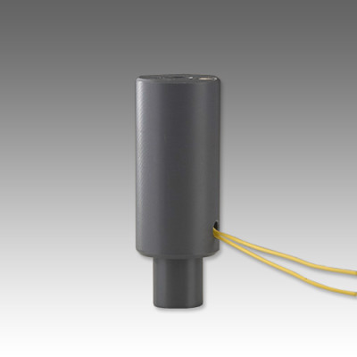
The CCM series flow monitors use a magnetic piston that rests at the flow tube inlet. The position of the piston changes with the flow of gas or liquid, and this is sensed by an adjustable reed switch. It’s ideal for this kind of application where flow rates are low and abnormal operating conditions must be sensed quickly.
Product Features:
- Adjustable Flow Monitor
- High Resolution
- Works in Very Low Flow Environments
- Minimal Pressure Drop
- Gas and Liquid Flow Sensor
- Materials: PVC
- Confirms: Normal flow conditions
- Senses: high flow, low flow
- Output: Switch Contact

