Cooling Towers & Chillers
Flow Monitor Application
LPH Series
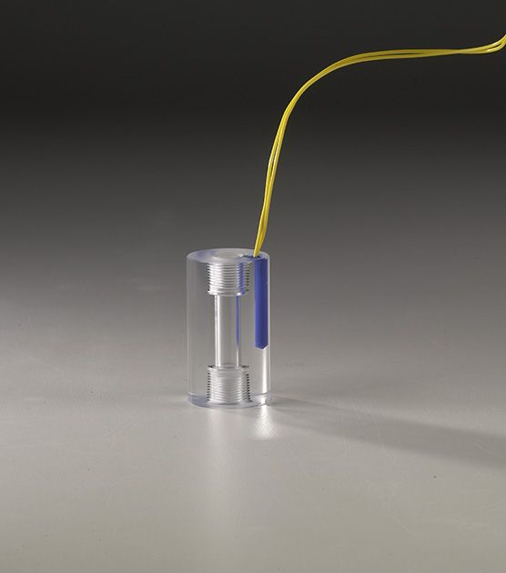

Problem:

Ensuring the constant rate of flow of cooling water in a chiller or cooling tower is a crucial part of the cooling process. Detecting an increase or decrease in flow can help prevent quality problems and damage to expensive equipment.

Application:
Water chillers & cooling towers benefit from the use of flow monitors to accurately maintain the efficiency of the water chiller or cooling tower. For instance, extracting heat from the incoming water requires the monitoring of air flow and circulating water rate. Flow monitors are employed to maintain the accurate balance of recirculated water and the water to air flow. The flow monitor is placed on the circulating water line to monitor flow rate. A second flow monitor is placed on the water line to monitor the rate of flow.

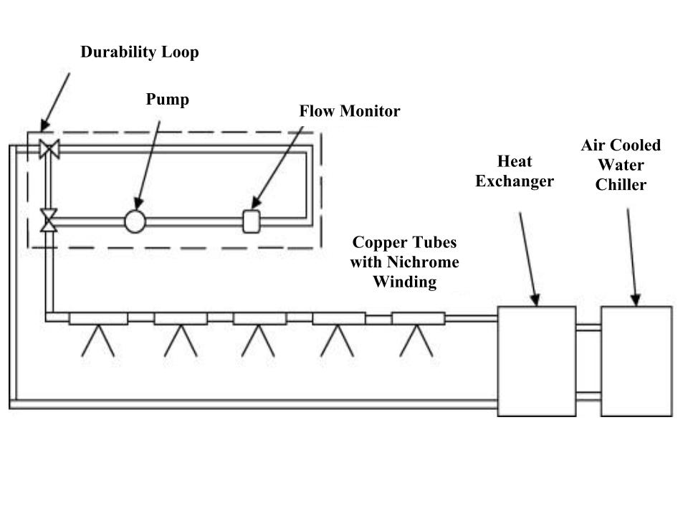

Solution:

Install ChemTec’s LPH Series Flow Monitor in line to monitor the flow rate through the chiller to detect changes in flow conditions and prevent damage to equipment.

ChemTec Flow Monitors Key Features:
- Compact Design
- Visual Indication of Flow
- Accurate
- No Seals
- Senses High & Low Flow Conditions
- Economical
- Customizable

For More Information:
Contact ChemTec at 800-222-2177 or visit our web site at www.chemtec.com.

