ChemTec: Wastewater Treatment
Wastewater Industry

Municipal, residential and industrial wastewater is a hot topic. Whether regarding the cleanliness and safety concerns for potable water used for farming, wastewater as a source of energy, dangerous bi-products of fracking wastewater; wastewater applications seem endless. Before wastewater can be reused, it must be treated. Deodorization, disinfection, scrubbing, separation, de-ionization, degasification, reoxidization are just a few of the treatments used. These applications, in addition to liquid chromatographs, wastewater deodorization & disinfection machines, odor scrubbers, cooling towers, lift stations, pump houses, ozone generators, and more can all use ChemTec’s durable line of flow meters and flow monitors.

ChemTec’s Related Products: MAO Series
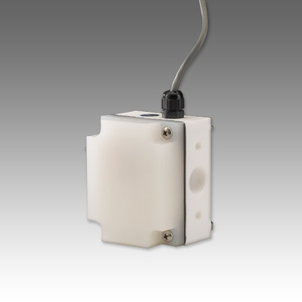

Features:
- No bearings
- Single moving part
- In-line metering
- No rotating internals
- Measures low flows
- PVC available

Applications:
- Wet Benches
- Cooling Systems
- Corrosive Chemical Dispensing
- Materials Consumption Measurement
- Process Controls
For more information call us at 1.800.222.2177 or contact the ChemTec sales department at info@chemtec.com.

