ChemTec: Cryogenics in Food Preservation

Freezing Technology: Cryogenics
Cryogenic freezing is still a relatively new method to food preservation that is gaining popularity due to its low set up costs and improved food quality when compared to other freezing technologies. Cryogenics freezing is not connected to a refrigeration plant; instead the refrigerants used are liquefied in large industrial installations and shipped to factories in large vessels – this allows for flexibility in design and efficiency!
Industry Growth
The frozen food market is one of the largest and most dynamic sectors of the food industry. In fact in 2012 the frozen food market was valued at $224.74 billion – and is expected to be more in the upcoming years! In fact, this industry is forecasted to grow by 3.9% (CAGR) by 2019. We can attribute this markets growth to the increasing number of women in the workforce, busy lifestyles of individuals and families and the wide range of frozen products available to consumers. – Research and Markets 2013
Related ChemTec Products
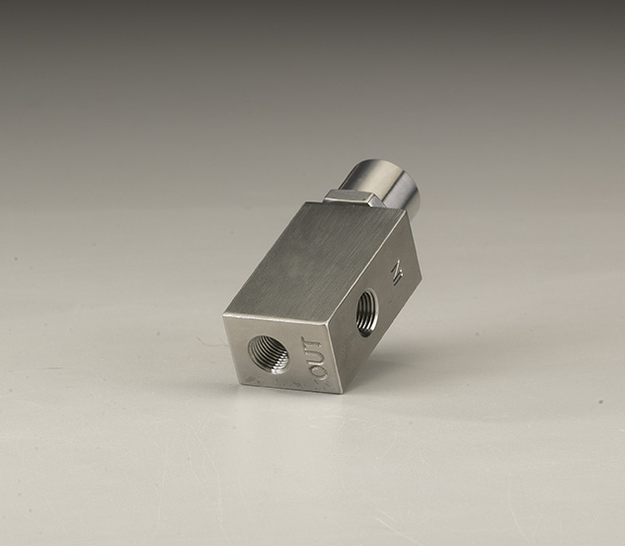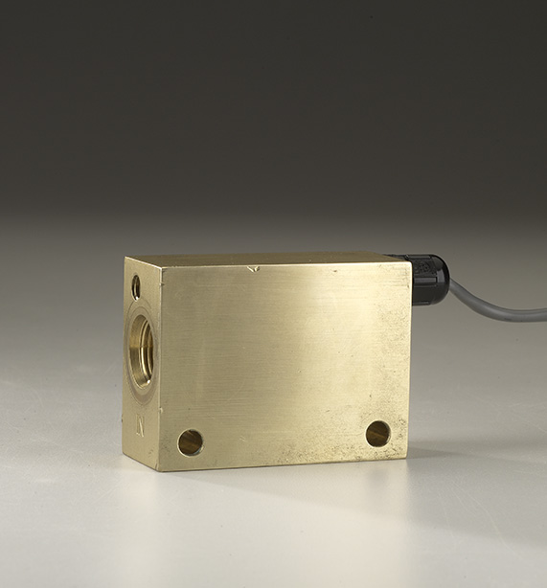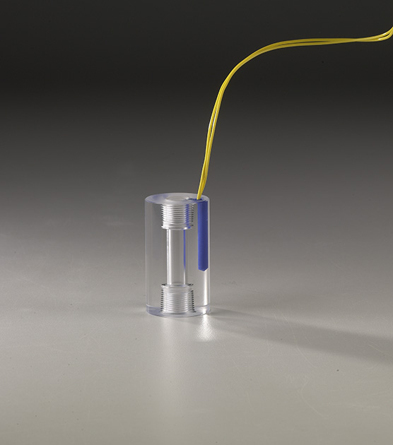
Excess Flow Valves LCA Flow Monitor LPH Series
- Compact size
- Most economical
- Close on/off differential
- Materials: Acrylic, Brass, 316ss or Teflon

For more information call us at 1.800.222.2177 or contact the ChemTec sales department at info@chemtec.com.

- Economical, best for loss of flow detection
- Adjustable
- Confirms: normal flow conditions
- Senses: high/low flow conditions
- Output: switch contact
- Controls excessive flows
- Controlled bleed, Resets automatically
- Field adjustable
- Positive shut-off
- Attitude variable mounting
- Function: Restricts or Shuts off flow
- Output: Switch contact optional
- Materials: 316ss or Brass body

