ChemTec: Automatic Spray Systems
Mosquito Misting Systems

Summer is here, and with the long days and rising temperatures come the mosquitos. The top months for mosquito presence are June, July and August and no one is safe from mosquito borne illnesses like West Nile Virus. It’s time to protect your home and yourself, but what’s the best way to get rid of them? Mosquito control systems are automatic spray systems that can be installed outside, have an automatic timer, a pump, a motor and a pressure gauge all mounted on top of a 55-gallon drum that holds the insecticide solution. Fort Lauderdale is one of the top 20 worst cities for mosquitos, so there are companies in need of flow monitors and meters to monitor dosing of the solution and to signal fluid in the line.
ChemTec’s Related Products: MAO Series

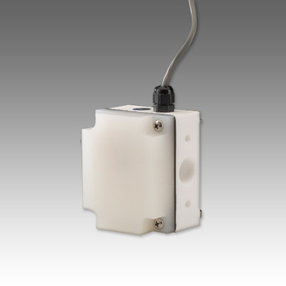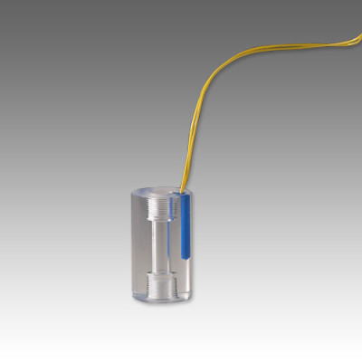
Features:
- Close On-Off Differential
- Visual Indication of Flow with Acrylic Model
- No Seals
- In-line Vertical Plumbing
- Material: Acrylic, Brass, 316SS or Teflon
How it Works
- ChemTec’s MAO Series flow meter is a reliable, accurate, economical low flow meter that can send a signal to a computer controlled and remote controlled process, such as automatic mosquito misters.
- The LPH Flow Monitor can additionally help these automatic sprinkler systems control the dosing of fluid in order to avoid overuse or failure.

Features:
- No bearings, single moving part
- In-line Metering
- No rotating internals
- Measures low flows
- All PVC wetted parts available

For more information call us at 1.800.222.2177 or contact the ChemTec sales department at info@chemtec.com.

