ChemTec: Reverse Osmosis Desalination
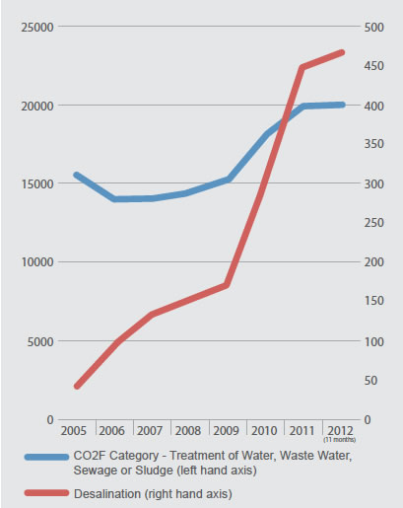
Importance & Growth
There is an increased need worldwide for fresh, pure water and reverse osmosis seems to be the answer. This method has been around for decades, but has never been this cost effective and efficient until recently.
The demand for these systems has opened new sales avenues in multiple industries. From home appliance manufacturers to cruise ships and even luxury yacht builders; the desalination industry is growing 15% per year. This growth will only continue to rise as the population increases and the fresh water reserves are consumed. In fact, according to the International Desalination Association, between 2001-2011 the industrial capacity for desalination water expanded 267 percent.
– Pacific Rim RO 2013
Related ChemTec Products
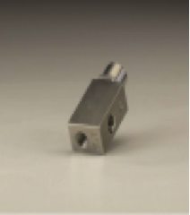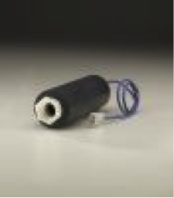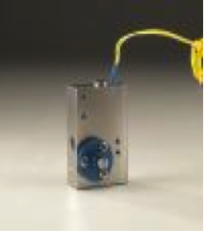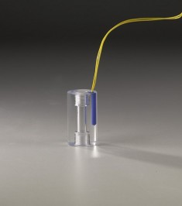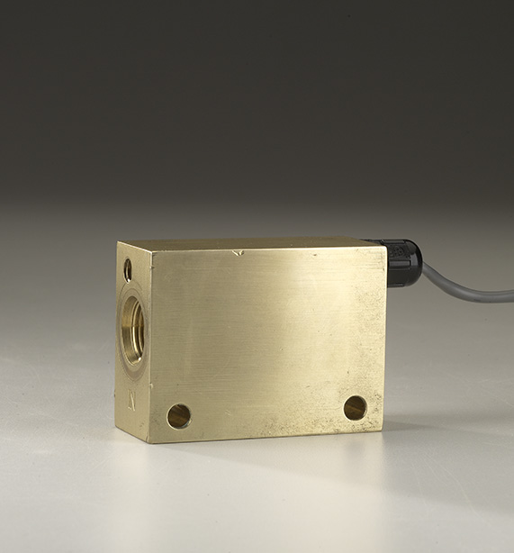
EFV-250-Series FS-B-846 125-316-BP LPH Series LCA Series

How These Products are used in Reverse Osmosis Desalination
- ChemTec’s flow monitors, flow meters and excess flow valves are a great addition to RODS. Installed to protect pumps, monitor flow, signal flow/no-flow conditions for quality, monitor operating pressures and fresh water flush upon shutdown.
- ChemTec’s flow meter offers digital and analog outputs capable of sending a signal to a main control to monitor the efficiency of the R/O system.
- All of ChemTec’s products are offered in materials suitable for use in seawater, to resist corrosion.

