ChemTec: Beauty Lasers
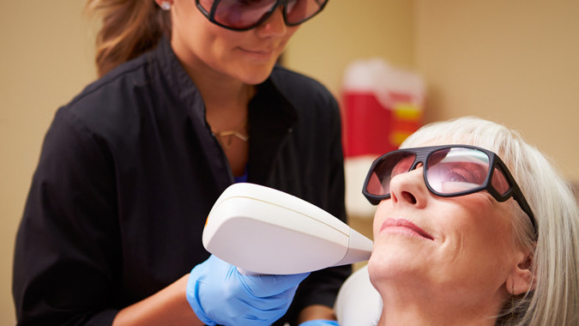
About the Beauty Laser Industry
Crank up a laser’s power and you can cut steel, turn it on and off quickly and you can transmit data. Or match the wavelength to the absorption of the target, and use it for selective heating. That’s the principle behind facial resurfacing: IR light passes through the outer layers of skin and is absorbed by water beneath. This creates localized heating, encouraging the formation of new collagen and elastin. After a few days recovery skin looks younger and wrinkles are reduced. Consumers like the speed and cost, (usually under $2,000,) and demand is rising rapidly.
Industry Growth
Reports value the aesthetic laser medical spa market at $2 billion by 2013 and $3 billion by 2017. That’s a lot of lasers, especially when, as Laser Focus World reports, “… spa start-up costs range from $700,000 to $1 million, with up to half of that devoted to buying or leasing the latest laser machines.” Lasers need cooling systems. These are predominantly liquid-based although some air-cooled YAG lasers are available. Reliability is a key parameter in component selection: should the laser get too hot it will stop working and could suffer expensive damage.
Featured Product: HPEFV
A flow monitor quickly detects problems in a cooling system, and can be used to safely shut down laser operation.

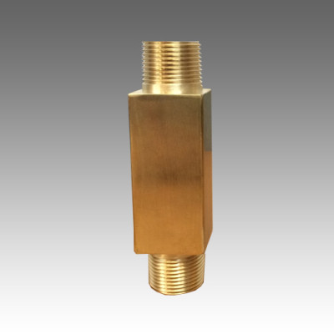
Product Features:
- Non-Adjustable Flow Monitor
- Low Maintenance
- Close On-Off Differential
- No Seals
- Single Moving Part
- In Line Vertical Plumbing
- Materials: 316ss, Brass or PVC
- Confirms: Normal Flow Condition
- Senses: High flow or Low flow
- Output: Switch Contact

